Enterprise Infrastructure and Networks – IT-520-A

Mallika Regulla

Marymount University

1. The two access points that are issuing most of the beacon frames have an SSID ’30 Munroe St’ and ‘Linksys12’

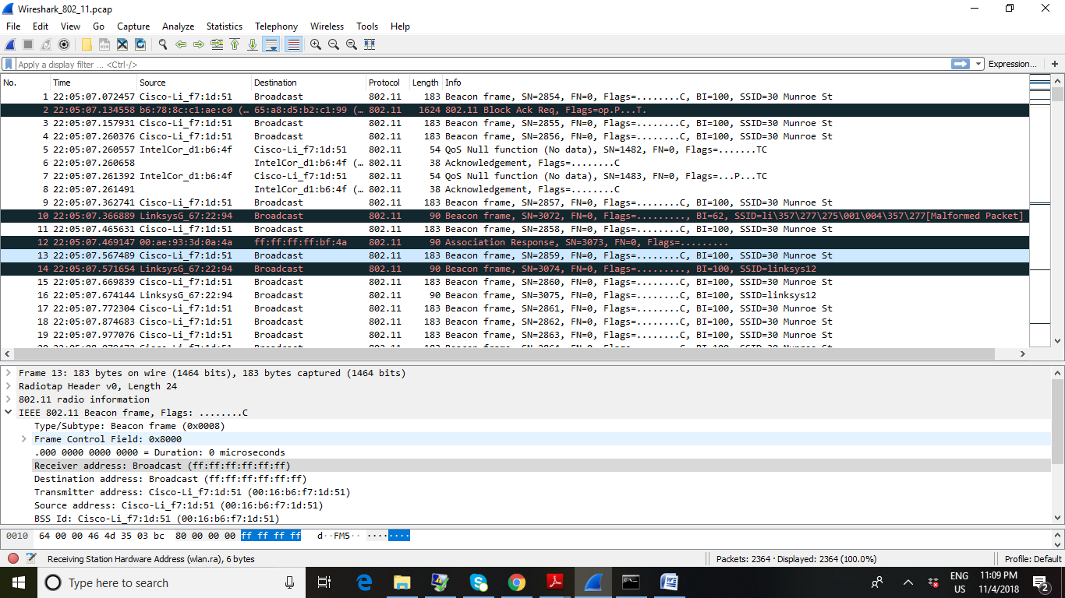

1. The beacon time interval is 0.102400 seconds

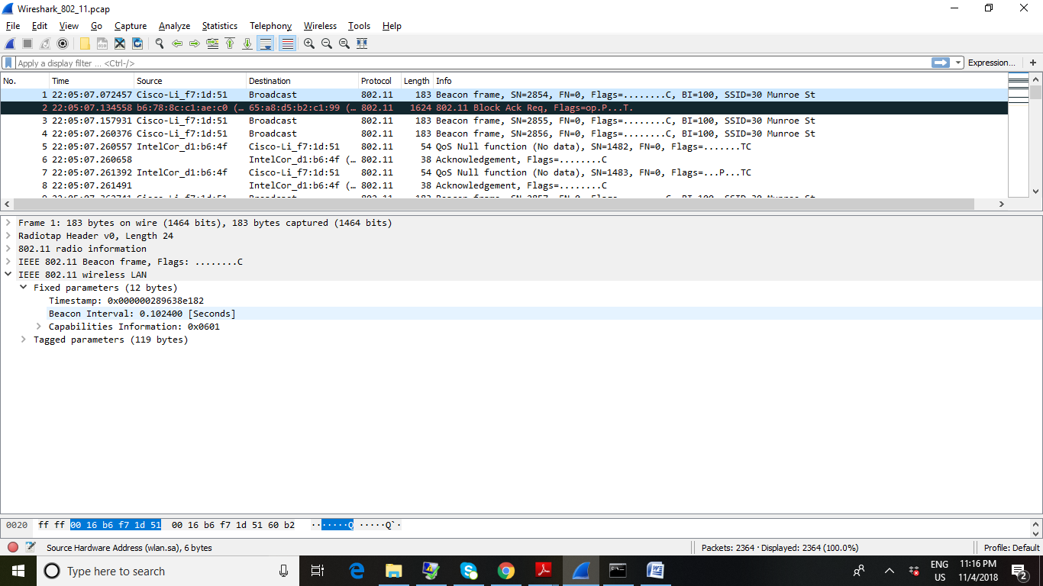

1. The source MAC address is (00:16:b6:f7:1d:51)

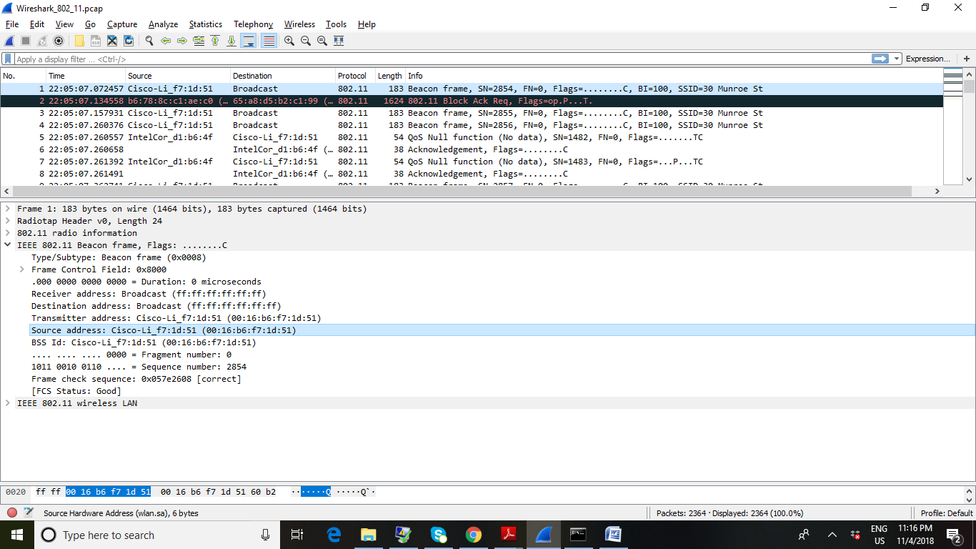

1. The destination address is(ff:ff:ff:ff:ff:ff)

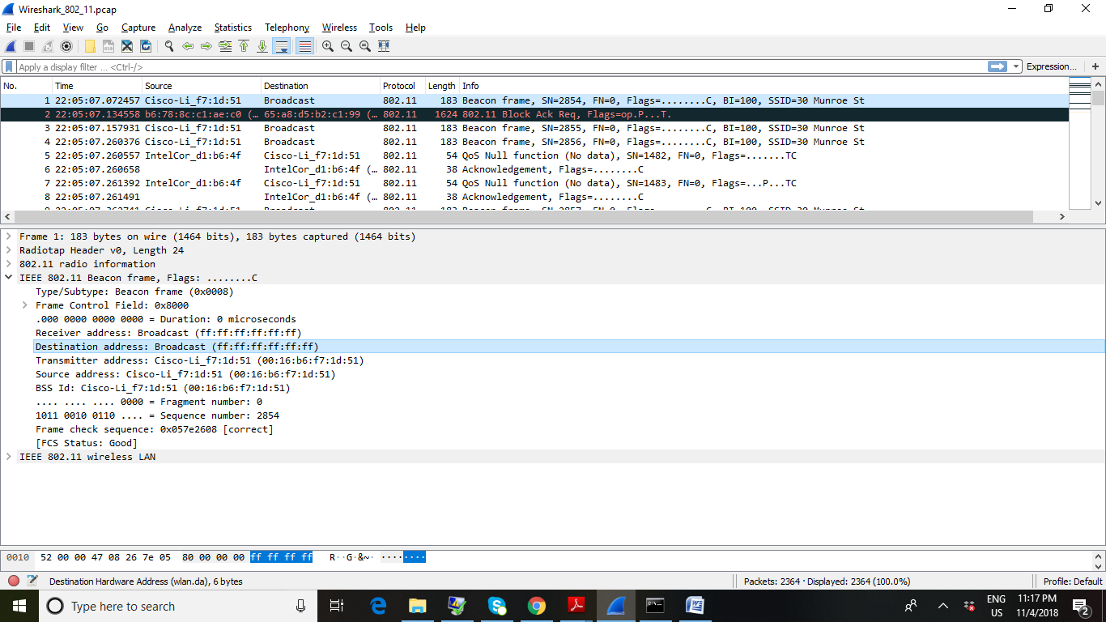

1. The BSS Id is (00:16:b6:f7:1d:51)

